26.24: After switching the 5-V battery for a 20-V battery in the circuit of Fig. 26.42,
there is a change in the equations from Problem 26.22 in both the upper and lower loops:
Upper loop:
Lower loop:
Along with 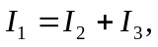we can solve for the three currents and find:
b)

